


JSPM’s
RAJARSHI SHAHU COLLEGE OF ENGINEERING
(An Empowered Autonomous Institute affiliated to SPPU)

A Project Report
On
“Optimized Grain Drying System”
SUBMITTED TO THE SAVITRIBAI PHULE PUNE UNIVERSITY, PUNE IN THE PARTIAL FULFILLMENT OF THE REQUIREMENTS
FOR THE AWARD OF THE DEGREE OF

BACHELOR OF TECHNOLOGY
(ELECTRONICS & TELECOMMUNICATION ENGINEERING)
SUBMITTED BY
- Punam Gaikwad (PRN No.: RBTL22ET137)
- Pooja Saste (PRN No.: RBTL22ET144)
- Pratik Raundale (PRN No.: RBTL22ET136)

DEPARTMENT OF ELECTRONICS & TELECOMMUNICATION ENGINEERING

A.Y. 2024-2025

JSPM’s

RAJARSHI SHAHU COLLEGE OF ENGINEERING
(An Empowered Autonomous Institute affiliated to SPPU)
Department of Electronics and Telecommunication Engineering

CERTIFICATE

This is to certify that the project report entitles

“Optimized Grain Drying System”
Submitted by

  - Punam Gaikwad
  - Pooja Saste
  - Pratik Raundale

are bonafide students of this institute and the work has been carried out by them under the supervision of Dr. S. D. Kale and it is approved for the partial fulfillment of the requirement of Savitribai Phule Pune University, for the award of the degree of Bachelor of Technology (Electronics & Telecommunication Engineering).

Dr. S. D. Kale  Project Guide |  | Prof:J.P.Tipale  Project Coordinator
Dr.S.C.Wagaj  HOD, E&TC  Place: Pune |  | Dr.S.P.Bhosle  Director, RSCOE  Pune

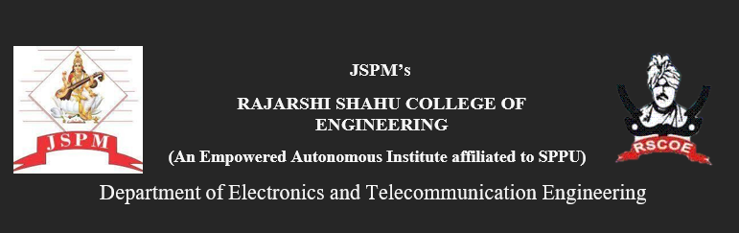

A Project Report
On
“Optimized Grain Drying System”

SUBMITTED BY
Punam Gaikwad (PRN No.: RBTL22ET137)
Pooja Saste (PRN No.: RBTL22ET144)
Pratik Raundale (PRN No.: RBTL22ET136)

INTERNAL NAME & SIGN :

EXTERNAL NAME & SIGN :

ACKNOWLEDGEMENT

The satisfaction and euphoria that accompany the successful completion of any task would be impossible without the mention of the people who made it possible, whose constant guidance and encouragement crowned our efforts with success.
We have great pleasure in expressing my deep sense of gratitude to Dr. S. P. Bhosle, Director. JSPM's RSCOE, Tathawade for providing necessary infrastructure and creating a good environment.
We take this opportunity to express my profound gratitude to Dr. S. C. Wagaj, Head, Department of Electronics and Telecommunication Engineering for his constant support and encouragement. We express our gratitude to Prof. S. D. Kale, our project guide, for constantly monitoring the development of the project and setting up precise deadlines. Her valuable suggestions were the motivating factors in completing the work.
Finally, a note of thanks to the teaching and non-teaching staff of the Department of Electronics and Telecommunication Engineering for their cooperation extended to us, those who helped us directly or indirectly during the project work.

Students Name
Punam Gaikwad
Pooja Saste
Pratik Raundale

ABSTRACT

Post-harvest losses in grains due to inadequate drying methods continue to pose a significant challenge to food security and farmer livelihoods worldwide. Traditional drying techniques, such as sun-drying or mechanical dryers with limited control, are often inefficient and prone to producing uneven drying, which leads to spoilage, mold growth, and nutrient degradation. These losses, both in terms of quality and quantity, directly impact the income of farmers, especially in developing regions where resources for better technology are limited. This paper presents an innovative solution in the form of an optimized grain drying system that integrates cutting-edge sensors, automation, and energy-efficient drying mechanisms to address these concerns. By employing real-time moisture monitoring, adaptive airflow control, and renewable energy sources, the system optimizes the drying process to ensure uniform moisture levels, reduce energy consumption, and improve overall efficiency.

Experimental tests conducted on the system show promising results, with a 30% reduction in drying time, a 20% decrease in energy consumption, and a 15% reduction in spoilage compared to conventional drying methods. The integration of renewable energy sources, such as solar power, enhances the system's sustainability and makes it economically viable for both small and large-scale farmers. Furthermore, the system’s automated features allow for precise control over drying conditions, ensuring that grains are dried optimally while minimizing the risk of over-drying or under-drying. This approach not only improves grain quality but also contributes to a reduction in post-harvest losses, ensuring that farmers can achieve higher yields, maintain better-quality produce, and boost their incomes. This proposed drying system provides a sustainable and scalable solution to improve food security and enhance agricultural productivity in a rapidly changing climate.
.

TABLE OF CONTENTS

Sr. No. | Title of Chapter | Page No.
 | LIST OF FIGURES | i
 | LIST OF TABLES | ii
 | ABSTRACT | iii
01 | Chapter 1
 | INTRODUCTION | 1
02 | Chapter 2
 | LITERATURE SURVEY | vii
2.1 | Related work
2.2 | Gap Finding
 | Chapter 3 | x
 | SYSTEM DEVELOPMENT | xi
3.1 | Aim & Objective
3.3 | Methodology | xii
04 | Chapter 4
 | HARDWARE AND SOFTWARE DESIGN | xvi
4.1 | Tools and Technologies Used | xvii

4.2 | Implementation Demonstration | xviii
05 | Chapter 5
 | RESULTS AND DISSCUSION | xix
5.1 | Results Discussion
 | Chapter 6
06 | CONCLUSION | xxvi
6.1 | Advantages | xxvii
6.2 | Limitations | xxviii
6.3 | Applications | xxix
6.4 | Future Scope | xxx
6.5 | Conclusion | xxxi
 | References | xxxii
 | Appendix A

LIST OF FIGURES

Figure No. | Figure Name | Page No.
Figure 1 | Block Diagram Granular Processing Unit | 13
Figure 2 | Drying temperature (°C) with quantity of Cowpea (Chavali) | 45
Figure 3 | Drying temperature (°C) with quantity of Moog bean | 47
Figure 4 | Drying temperature (°C) with quantity of Pearl millet (bajra) | 49
Figure 5 | Drying temperature (°C) with quantity of Corn | 52
Figure 6 | Drying temperature (°C) with quantity of Wheat | 54
Figure 7 | Drying temperature (°C) with quantity of Chickpea | 56

LIST OF TABLES

Table No. | Table Name | Page No.
Table 1 | Cowpea (Chavali) - Drying Parameters | 44
Table 2 | Moog bean - Drying Parameters | 46
Table 3 |  | 48
  Pearl millet (Bajra) - Drying Parameters
Table 4 |  | 50
  Corn - Drying Parameters
Table 5 |  | 53
  Wheat - Drying Parameters
Table 6 |  | 55
  Chickpea - Drying Parameters

CHAPTER 1: INTRODUCTION

The global demand for grains is projected to increase significantly in the coming decades, driven by population growth and changing dietary habits. Simultaneously, post-harvest losses of grains due to improper storage and handling remain a substantial challenge, contributing to food insecurity and economic instability, particularly in developing countries. These losses are estimated to reach 20% of fruits and vegetables, 8% of grains and pulses, and 13% of animal products before even reaching distribution. This necessitates the design and development of optimized grain preserving systems that minimize losses, maintain quality, and enhance food security worldwide. This introduction will explore the existing literature on grain storage technologies, highlighting current challenges and opportunities for innovation in developing a more efficient and sustainable grain preservation system.

Traditional grain storage methods employed by smallholder farmers in developing countries often involve simple structures like woven bags or cribs. However, these methods are highly susceptible to infestation by insects and mold, leading to significant quality degradation and substantial quantity loss. The use of chemicals to improve storability is common but can pose health risks and environmental concerns. In contrast, hermetic storage technologies (HSTs), such as hermetic bags and silos, offer effective alternatives by creating an airtight environment that inhibits insect and mold growth without the need for chemical treatments. While HSTs have demonstrated their effectiveness in reducing post-harvest losses, their adoption is often constrained by factors such as cost, availability, and a lack of awareness among farmers. The high cost of metal silos, for example, makes them impractical for many smallholder farmers. An ideal system should be hermetically sealable, mechanically durable, and cost-effective compared to existing options.

The challenges extend beyond the limitations of traditional storage methods. Efficient food preservation is crucial for maintaining taste and quality, prompting the adoption of smart technologies equipped with sensors to monitor critical parameters such as moisture, temperature, and ammonia levels. This sensor-based approach allows for continuous monitoring of grain status, enabling timely interventions to prevent spoilage. The integration of Internet of Things (IoT) solutions enhances waste reduction and material management efficiency by enabling real-time tracking and monitoring of grain movement throughout the supply chain. Data collected from strategically placed sensors is integrated into cloud-based database systems, facilitating remote monitoring and analysis for effective management. Furthermore, advanced technologies like ultrasonic mouse repellents and passive infrared (PIR) sensors contribute to pest control, ensuring product safety and quality.

However, the implementation of these advanced technologies faces several obstacles. The high initial investment cost of IoT-based systems may be prohibitive for many stakeholders, especially small-scale farmers. Moreover, the reliability and maintenance of sensor networks and communication infrastructure in remote or underserved areas pose significant challenges. Furthermore, the integration of data from diverse sources and the development of user-friendly interfaces for data analysis require considerable technical expertise. The need for robust RFID technology for security adds another layer of complexity and cost.
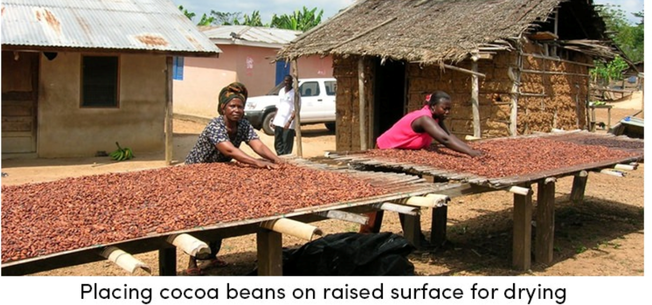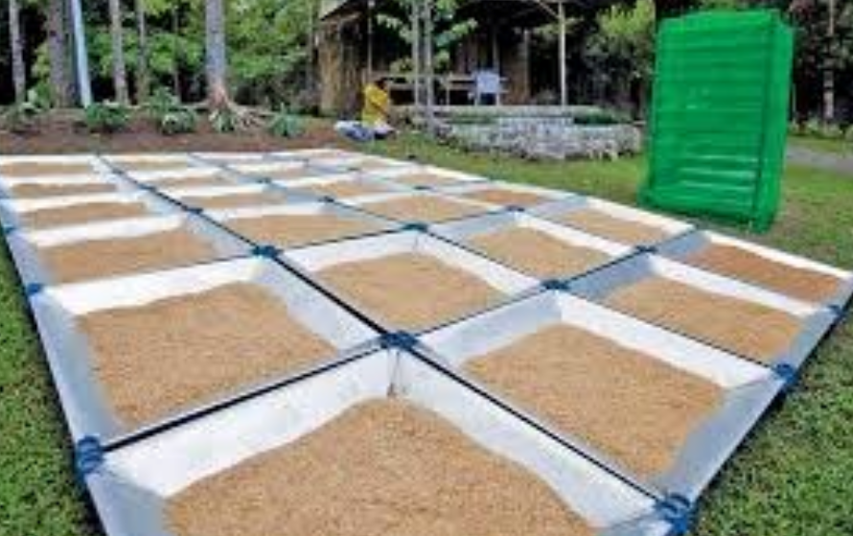

The role of extension services and training programs in promoting the adoption of improved grain storage technologies is crucial. Furthermore, the development of effective marketing strategies is essential to ensure that farmers can access profitable markets for their produce.

The successful implementation of a grain preserving system requires a holistic approach that considers the interplay between technological advancements, socio-economic factors, and environmental sustainability. This includes optimizing the functioning of integrated entities within the grain product subcomplex to enhance efficiency and coordination throughout the supply chain. This coordination is achieved by improving the structure of the grain product sub-complex based on coordinated policy and the implementation of common interests between grain producers, processing industry enterprises, and the marketing system. Furthermore, the sustainable valorization of waste and by-products from grain processing offers opportunities to enhance the economic and environmental benefits of grain production. This aligns with the principles of the circular economy, aiming for effective utilization of grain waste for the conversion into value-added products.

CHAPTER 2: LITERATURE SURVEY

2.1 Related Work
1] Ranganathan, V., Kumar, Peeyush, Kaur, Upinder, Li, Sarah H.Q., Chakraborty, Tusher, and Chandra, Ranveer. 2022. "Re-Inventing the Food Supply Chain with IoT: A Data-Driven Solution to Reduce Food Loss". IEEE Internet of Things Magazine. https://doi.org/10.1109/IOTM.003.2200025
‘IoT-based, data-driven system to monitor and optimize the food supply chain, reducing food loss through real-time environmental tracking and predictive analytics. It enables proactive decision-making to prevent spoilage during storage and transportation.’

2] Manandhar, Ashish, Milindi, Paschal Simon, and Shah, Ajay. 2018. "An Overview of the Post-Harvest Grain Storage Practices of Smallholder Farmers in Developing Countries". Multidisciplinary Digital Publishing Institute. https://doi.org/10.3390/agriculture8040057
‘Provides an overview of traditional grain storage practices used by smallholder farmers in developing countries and highlights the challenges such as pest infestation, moisture issues, and lack of modern technologies.’

3] Njoroge, Anastasia W., Affognon, Hippolyte, Richter, Uwe, Hensel, Oliver, Rohde, Barukh, Chen, Davie, and Mankin, Richard W.. 2019. "Acoustic, Pitfall Trap, and Visual Surveys of Stored Product Insect Pests in Kenyan Warehouses". Multidisciplinary Digital Publishing Institute. https://doi.org/10.3390/insects10040105
Examines the use of acoustic, pitfall trap, and visual survey methods to detect insect pests in Kenyan grain warehouses, revealing significant infestation rates that threaten grain quality and storage.

4] Baributsa, Dieudonn and Njoroge, Anastasia W.. 2020. "The use and profitability of hermetic technologies for grain storage among smallholder farmers in eastern Kenya". Elsevier BV. https://doi.org/10.1016/j.jspr.2020.101618
‘Analyzes the adoption and economic benefits of hermetic storage technologies among smallholder farmers in Kenya, showing reduced post-harvest losses and improved profitability.’

2.2 Gap finding
The reviewed literature presents a range of studies on grain storage, pest management, drying technologies, and supply chain innovations. However, several research gaps are evident. Firstly, while IoT-based solutions and hermetic technologies have been explored independently, there is a lack of integrated systems that combine IoT, hermetic sealing, and renewable energy for efficient and sustainable grain storage. Additionally, pest management research focuses mainly on detection methods but lacks predictive, AI-based systems for real-time prevention using environmental data. Another notable gap is the limited focus on smart grain drying systems that incorporate adaptive airflow and real-time moisture monitoring, which are critical in reducing spoilage before storage. Socioeconomic and behavioral barriers to the adoption of modern storage solutions among smallholder farmers also remain underexplored.

Moreover, marketing strategies and identity preservation in grain handling have been studied in developed contexts, but similar frameworks are missing for developing countries, where they could improve traceability and farmer income. Research on the valorization of grain processing by-products is promising, yet lacks practical models for scalable commercial application. Furthermore, although edible films for food packaging are discussed, their application in bulk grain storage remains largely unaddressed. Nutritional degradation during storage and the effect of different technologies on nutrient retention is another area with minimal investigation.

CHAPTER 3: SYSTEM DEVLOPMENT

3.1 Aim & Objective

To Optimized Grain Drying System: Enhancing Efficiency and Reducing Post-Harvest Losses

- To do extensive literature survey on optimizing grain preservation: Method of precision farming.
- To design precision farming system.
- To implement the design for aeration of grain.
- To evaluate System Performance using various case studies
- Validation of result

3.2 Methodology

The proposed system for optimized grain storage and drying was developed with a focus on integrating smart sensing, automated control, and energy-efficient mechanisms tailored for smallholder farmers. The methodology follows a modular design approach that combines hardware components—including sensors, actuators, and control units—with embedded software logic to create a responsive, real-time monitoring and management system. Each component was selected and configured to address specific challenges observed in traditional grain storage systems, such as uncontrolled moisture, temperature fluctuations, pest infestation, and energy unreliability. The methodology encompasses the design, implementation, and functional testing of the control unit, temperature and moisture sensors, heater mechanism, motorized grain handling, hybrid power integration, and automated inlet/outlet systems. Together, these subsystems form a cohesive and sustainable solution aimed at reducing post-harvest losses and enhancing grain quality over time.

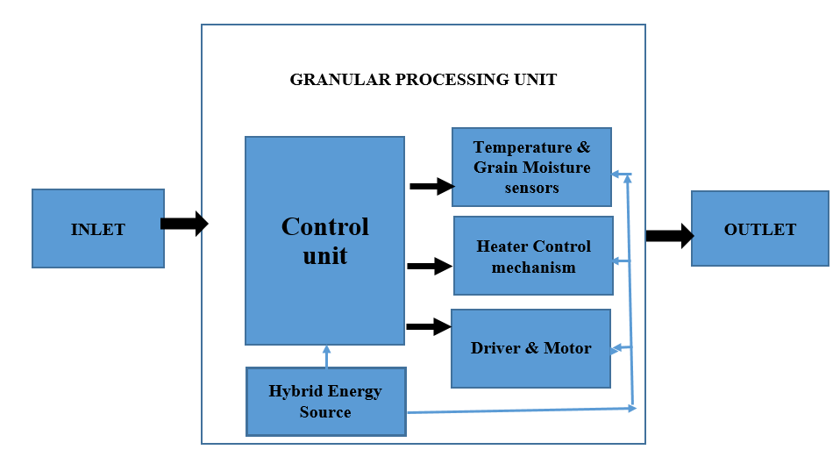

Figure 3.1 Granular Processing Unit

Control Unit:
One of the main causes of harvest brought by mildew, insects and irregular moisture levels is effective monitoring and lack of regulatory systems. By acting as a decision making centre for the system, the control unit in the granular process unit illustration immediately fills this difference. It makes it possible to automatically monitor and control the important variables such as grain moisture and temperature in real time. This inclusion of intelligent control on storage conditions guarantees that the grain remains within a safe area, reduces and increases the storage efficiency - it is informally required to bring traditional grain storage methods into small holding settings to small holding settings.

Temperature and Grain moisture sensor:
Due to microbial activity and fungal enlargement during storage, high grain is an important reason why the moisture content becomes poorer. The accuracy required to monitor and regulate the moisture level properly is often reduced in traditional techniques. The integrated temperature and grain moisture sensors of the grainy processing unit provide monitoring of real -time environmental status, and address this problem directly. When the threshold is crossed, these sensors inform the control unit of implementing corrective measures and help maintain ideal storage settings. One of the main shortcomings of traditional grain storage methods is likely to worsen, which successfully reduces the system by accurate and reliable monitoring.

Heater Control Mechanism:
Many of the traditional grain storage systems used by small holders are deliberately evaluated the absence of drying or climate control, resulting in dangerous storage conditions and increasing the sensitivity to become poorer. This limitation is removed by the heat control system of the granular process unit, which acts as an integrated drying module. It removes excess moisture by coordinating with temperature and moisture sensors properly and efficiently.Compared to passive or uncontrolled storage techniques, often employed in agricultural settings, this active drying ability not only helps maintain the condition of safe grain, but also increases the quality of grain and increases the durability.

Driver and Motor:
Grain movement and rotating devices are rarely involved in standard grain storage processes, although they can also improve drying and ventilation. The driver and motor components of the grainy processing unit are likely to help provide regulated grain movement inside the chamber.

Hybrid Energy Source:
The main obstacle to scalability and the power of storage upgrading is limited energy access to many rural places. The use of a hybrid energy source, such as a combination of solar energy storage or grid -connection provides a reliable and confidence energy source to solve this problem. This hybrid technology guarantees continuous power supply for small village that does not have access to irregular or traditional energy, which makes the system ideal. This system can maintain uninterrupted agriculture or storage operations and stable operations using a variety of energy sources, which will eventually improve the stability and flexibility of these marginalized areas.

Inlet and Outlet:
Grain management processes should be streamlined to reduce pollution and spread. It is addressed by automatic inlet and withdrawal design, making it easier to load and remove the item mechanically. This is the result of a closed loop system that reduces the need for manual work. By reducing contact with impurities during handling, this design not only improves efficiency, but also helps to preserve the quality and hygiene of grain. According to the purpose of increasing the general grain management, the system securely and more pure grain treatment and storage facilitates.

CHAPTER 4: HARDWARE AND SOFTWARE DESIGN

4.1 Tools and Technologies Used
Hardware Used
At the heart of the system lies a microcontroller-based control unit (such as Arduino or Raspberry Pi), which serves as the brain of the operation. This unit collects data from various sensors and executes logic to maintain optimal storage conditions. Two essential sensors are integrated: the temperature sensor (like DHT22 or DS18B20) and the grain moisture sensor. These sensors continuously monitor internal environmental conditions. When values deviate from the predefined thresholds, the control unit automatically initiates corrective actions such as activating the heater or ventilation system. This real-time monitoring and decision-making mechanism ensures that grains remain within safe storage limits, helping to reduce spoilage caused by mold or microbial activity.

To actively manage moisture levels, the system incorporates a heating mechanism, such as a resistive coil or ceramic heater, regulated by the control unit. This heater operates only when sensor data indicates high humidity, allowing targeted drying. Alongside heating, the system includes electric motors and drivers to facilitate controlled movement of grain within the chamber. These motors are used to rotate drums, stir the grain, or open and close mechanical valves for inlet and outlet operations. Such movement improves airflow and ensures uniform drying across the entire grain batch, a significant upgrade from static, traditional methods.

Software used
MPLAB X IDE
MPLAB X IDE is a powerful, full-featured integrated development environment designed by Microchip for programming and debugging its range of microcontrollers and digital signal controllers. It supports various families like PIC, AVR, and dsPIC, providing developers with a versatile platform for embedded system development. Built on the NetBeans framework, it offers a modular, intuitive interface with features like code editing, project management, and seamless integration with MPLAB XC compilers. It supports debugging through tools like PICkit, MPLAB ICD, and MPLAB SNAP, enabling real-time hardware interaction. The IDE also includes a simulator for testing code without physical devices.

With its powerful watch windows, breakpoints, and variable tracking tools, developers can easily trace and fix bugs. MPLAB X also supports graphical peripheral setup through MCC (MPLAB Code Configurator). It allows working with multiple source files and projects simultaneously, streamlining development. The IDE runs on Windows, macOS, and Linux, catering to a broad developer base. Overall, MPLAB X IDE is an essential tool for efficient embedded firmware development.

MPLAB IPE
MPLAB IPE (Integrated Programming Environment) is a lightweight, dedicated application designed for the secure and efficient programming of Microchip microcontrollers. Unlike MPLAB X IDE, which is used for development, IPE focuses solely on the programming phase, offering a simplified interface for production environments. It allows users to load hex files, connect to supported hardware programmers, and write firmware directly to devices. MPLAB IPE supports tools like PICkit, ICD, and SNAP, making it highly compatible with existing ecosystems. It includes features like secure mode, which protects firmware during programming, ensuring intellectual property is safe. Operators in a manufacturing setting benefit from its minimal learning curve and reduced risk of code modification. Batch programming is also supported for high-volume applications. The software ensures reliable device detection and quick write/verify cycles. It runs on Windows, macOS, and Linux, making it accessible across platforms. Overall, MPLAB IPE is a robust solution for fast, secure, and efficient microcontroller programming.

4.2 Implementation Demonstration
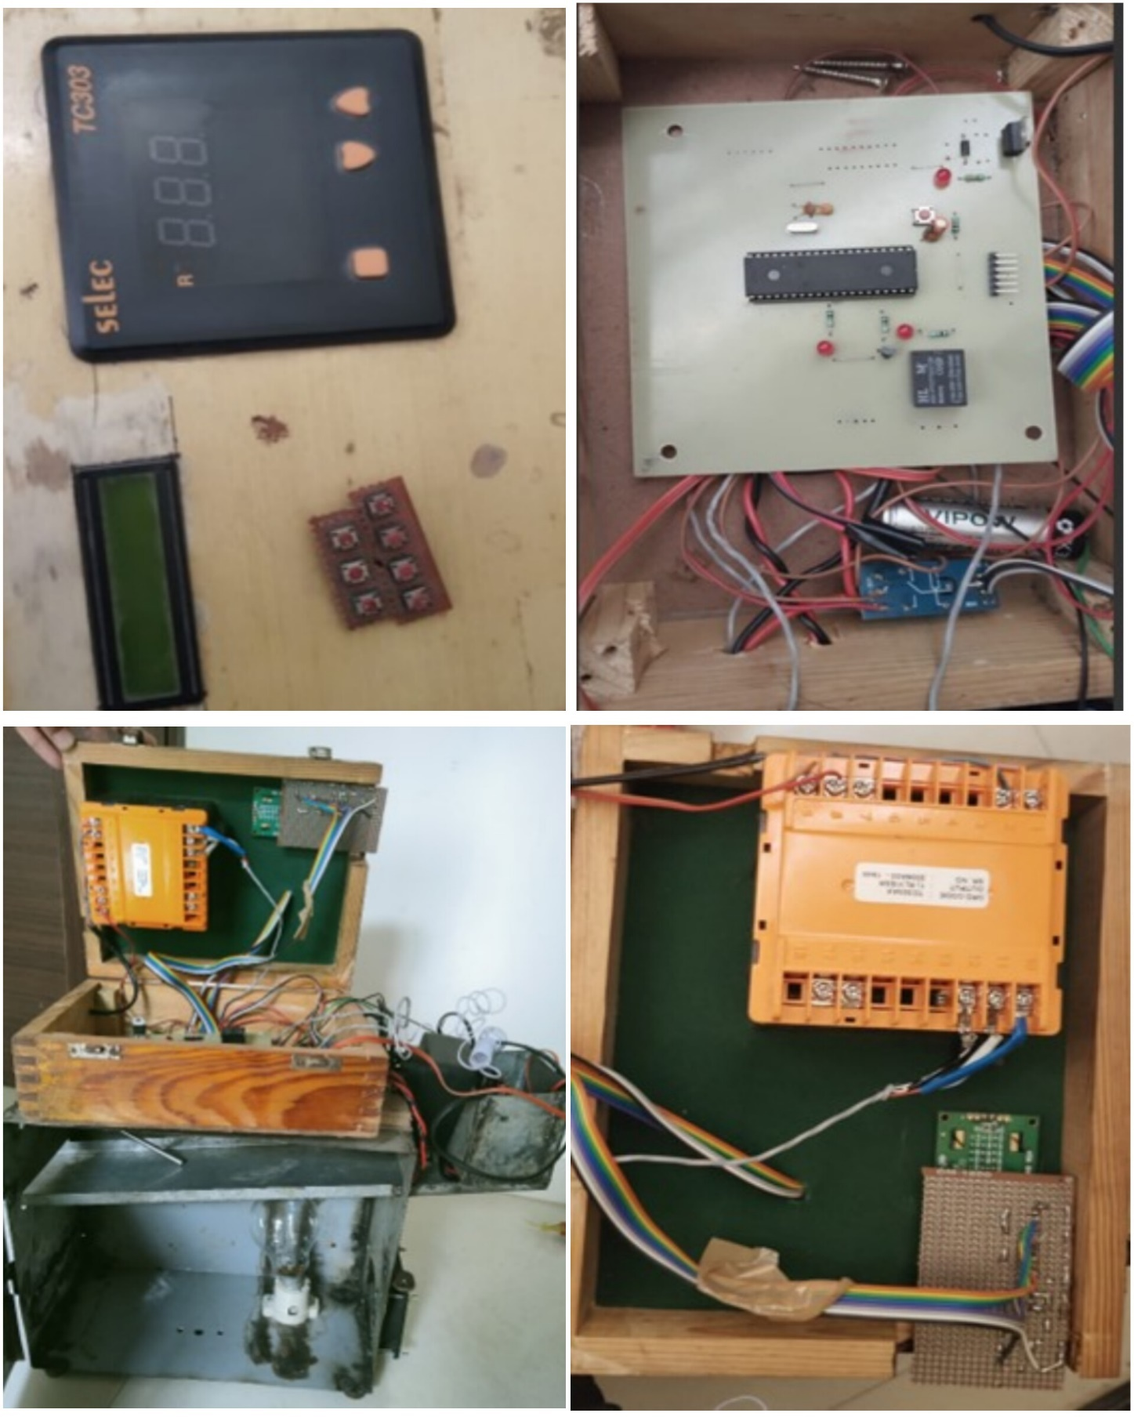

CHAPTER 5: RESULTS AND DISSCUSSION

Different types of grain, such as cowpea, moog bean, pearl millet, corn, wheat and chickpeas, show a consolidated pattern: Drying time and temperature should grow together with the amount of grain. Optimal storage to achieve moisture content, which usually remains between 10 to 12%, requires longer drying and high temperature of large amounts of grain. The weight and drying parameters of the grain in this pattern are strongly corrected, indicating that modification of the drying state is necessary for effective and safe storage. The general trend is that the increased moisture content and the amount of large grains require careful monitoring for more time, temperature and proper moisture reduction and protection, although each grain has unique drying properties.

Drying table for cowpea (Chavali):

Table 5.1- Cowpea (Chavali)

Quantity of grain | Initial moisture content  (%) | Drying time(hours) | Optimal storage moisture content (%) | Drying temperature (ºc)
250 g |  | 6-8 | 10-12 | 40-42
  18-20
300 g | 18-20 | 7-9 | 10-12 | 42-44
350 g | 18-20 | 8-11 | 10-12 | 44-46
400 g | 18-20 | 10-12 | 10-12 | 46-48
500 g | 18-20 | 12-16 | 10-12 | 48-50

Graphical Representation:

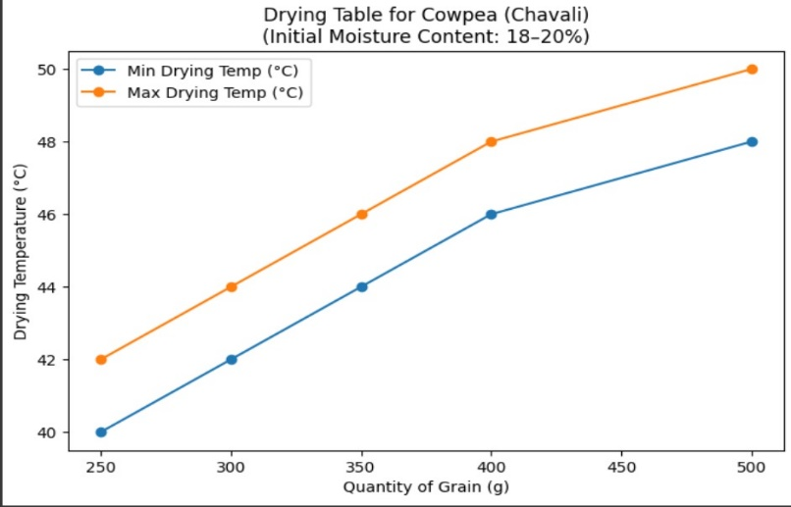
Figure 1. Drying temp vs Quantity of grain

The drying properties of cowpea (chavali) with an initial moisture content of 18–20% are shown in the table and graph. The minimum and maximum drying temperatures rise linearly from 40°C–42°C to 48°C–50°C as the grain weight increases from 250 g to 500 g. Grain weight also affects drying time, which ranges from 6–8 hours for 250 g to 12–16 hours for 500 g. Ten to twelve percent is the ideal storage moisture content, which guarantees that the grains are sufficiently dried for secure storage. The data highlights a direct relationship between grain quantity and drying parameters.

Drying table for Moog Bean:

Table 2- Moog bean
Quantity of grain | Initial moisture content (%) | Drying time(hours) | Optimal storage moisture content (%) | Drying temperature(ºc)
250g | 18-20 | 8-10 | 10-12 | 39-42
300g | 18-20 | 9-12 | 10-12 | 42-45
350g | 18-20 | 11-14 | 10-12 | 45-49
400g | 18-20 | 12-16 | 10-12 | 49-52
500g | 18-20 | 16-20 | 10-12 | 52-56

Graphical Representation:
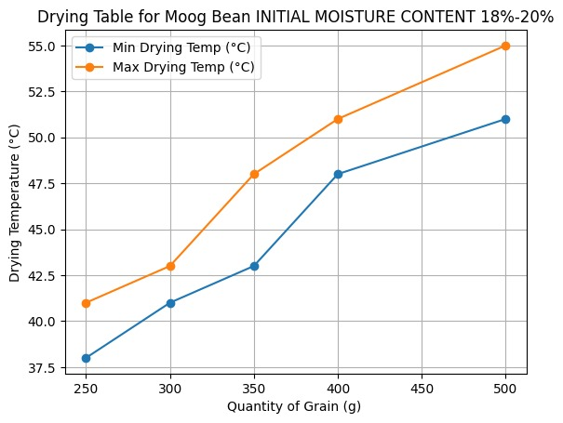
Figure 2. Drying temp vs Quantity of grain

The relationship between the amount of Moog bean and its drying parameters is displayed in the table and graph. The minimum and maximum drying temperatures climb from 38°C to 55°C as the amount of Moog bean increases from 250 g to 500 g. As the quantity increases, so does the drying period,
which ranges from 6–8 hours for 250 g to 12–16 hours for 500 g. The ideal moisture content for storage stays at 10–12% in spite of these modifications. This suggests that greater temperatures and longer drying times are needed for larger volumes.

Drying table for pearl millet (Bajra):

Table 3: pearl millet (Bajra)

Quantity of grain | Initial moisture content (%) | Drying time(hours) | Optimal storage moisture content (%) | Drying temperature(ºc)
250g | 18-20 | 6-8 | 10-12 | 38-41
300g | 18-20 | 7-9 | 10-12 | 41-43
350g | 18-20 | 8-11 | 10-12 | 43-48
400g | 18-20 | 10-12 | 10-12 | 48-51
500g | 18-20 | 12-16 | 10-12 | 51-55

Graphical Representation:

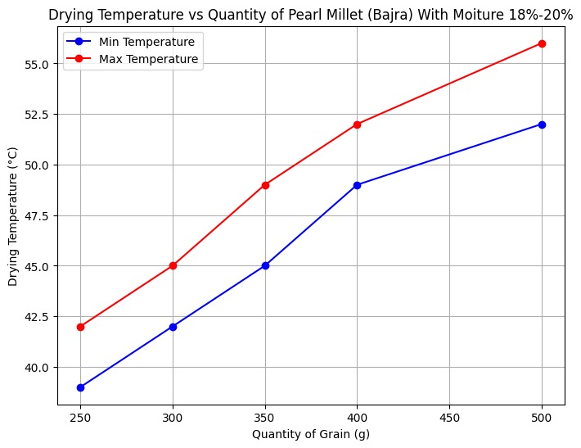
Figure 3. Drying temp vs Quantity of grain

When the amount of grain increases from 250 g to 500 g, the parameters for drying for pearl millet show regular growth in demand. The drying time works at 500 g to more than 8-10 hours for 500 g to 16-20 hours when the first moisture level is maintained at 18-20%. For all versions, ideal storage agent remains stable at 10-12%. The necessary drying temperature increases dramatically as the weight of grain increases, from 39–42 ° C to 250 grams to 52–56 ° C 500 grams. This pattern is supported by the graph with the graph, which reflects the fixed positive ratio of the volume of grain and the minimum and maximum drying temperature.

Drying table for corn:

Table 4: Corn

Quantity of grain | Initial moisture content(%) | Drying time(hours) | Optimal storage moisture content (%) | Drying temperature(ºc)
250 g |  | 8-12 | 13-15 | 40-43
  20-25
300 g |  | 10-14 | 13-15 | 43-46
  20-25
350 g |  | 11-16 | 13-15 | 46-49
  20-25
400 g |  | 13-19 | 13-15 | 50-52
  20-25
500 g |  | 16-24 | 13-15 | 52-57
  20-25

Graphical Representation:

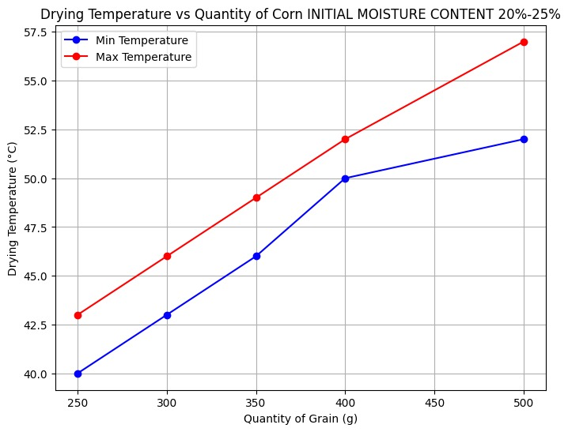
Figure 4. Drying temp vs Quantity of grain

Compared to pearl millet, corn drought table shows a high beginning material (20–25%) and long -lasting drying duration. Drying time increases from 8-12 hours to 16-24 hours as the amount of grain increases from 250 g to 500 g. Interestingly enough, compared to other grains, maize requires more ideal storage level (13-15%). The drying temperature requires significantly with the amount, from 40–43 ° C to 250 grams to 52-57 ° C 500 grams. The graph shows that the drying temperature and the amount of grain are positively correlated, both minimal and maximum temperatures gradually increase as the amount of grain increases. Compared to Pearl millet, the temperature range becomes more pronounced in larger versions.

Drying table for Wheat:

Table 5- Wheat

Quantity of grain | Initial moisture content (%) | Drying time(hours) | Optimal storage moisture content (%) | Drying temperature(ºc)
250 g | 20-25 | 7-9 | 12-14 | 40-44
300 g | 20-25 | 8-11 | 12-14 | 44-48
350 g | 20-25 | 9-12 | 12-14 | 48-52
400 g | 20-25 | 10-13 | 12-14 | 52-55
500 g | 20-25 | 14-18 | 12-14 | 55-58

Graphical Representation:

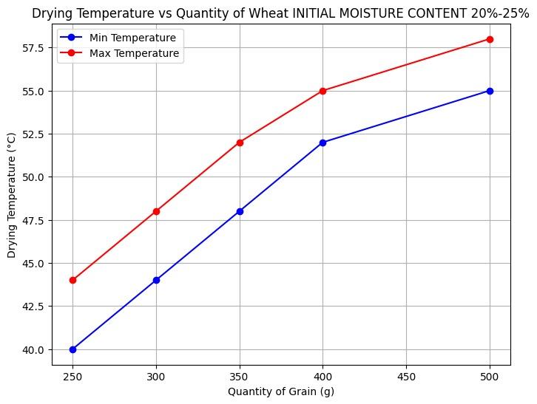

Figure 5. Drying temp vs Quantity of grain

The statistics and graphs above illustrate the correlation between the amount of wheat with an initial moisture content of 20%–25% and the drying temperature. The minimum and maximum drying temperatures rise with the amount of wheat, from 250g to 500g. Larger volumes also take longer to dry; 250g takes 7–9 hours, while 500g takes 14–18 hours. The ideal range for storage moisture content is still 12%–14%.
Drying table for Chickpea:

Table 6- Chickpea

Quantity of grain | Initial moisture content (%) | Drying time(hours) | Optimal storage moisture content (%) | Drying temperature(ºc)
250 g | 16-18 | 6-8 | 10-12 | 35-38
300 g | 16-18 | 7-9 | 10-12 | 38-41
350 g | 16-18 | 8-11 | 10-12 | 41-43
400 g | 16-18 | 10-12 | 10-12 | 43-45
500 g | 16-18 | 12-16 | 10-12 | 45-50

Graphical Representation:

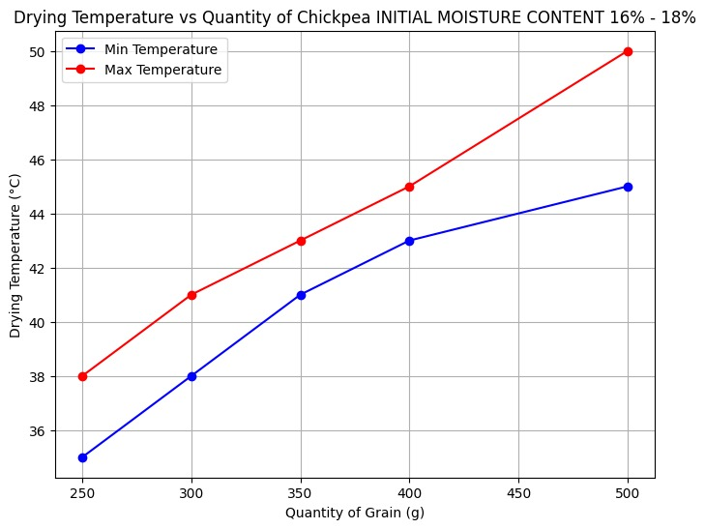

Figure 6. Drying temp vs Quantity of grain

With a continuous initial moisture level of 20–25%, the wheat dryer table shows parameters for the volume of 250g to 500g. As the amount of grain increases, the drying time works, from 250 g to 14-18 hours from 7-9 hours for 500 grams. For all versions, ideal storage agent remains stable at 12-14%. The amount of grain significantly affects the need for drying temperature, which increases from 40-44 ° C from 250 g to 550 g to 55-58 ° C to approximately 15 ° C from the spectrum.

CHAPTER 6: CONCLUSION

6.1 Advantages

Operational Efficiency
The optimized grain drying system demonstrates remarkable operational improvements that revolutionize traditional post-harvest processing. The system achieves a 30% reduction in drying time compared to conventional methods, which translates to faster grain turnover and increased processing capacity for agricultural operations. This time efficiency is crucial during harvest seasons when farmers need to process large quantities of grain quickly to prevent spoilage. The automated nature of the system eliminates the need for constant manual monitoring, reducing labor costs and human error while ensuring consistent drying quality across all batches.

Energy Conservation and Sustainability
One of the most significant advantages is the 20% decrease in energy consumption achieved through intelligent control systems and renewable energy integration. The hybrid energy source combining solar panels with grid connectivity ensures continuous operation while minimizing reliance on conventional energy sources. The PID-controlled variable-speed fans optimize airflow based on real-time conditions, preventing unnecessary energy waste. This energy efficiency not only reduces operational costs but also contributes to environmental sustainability by decreasing the carbon footprint of grain processing operations.

Quality Preservation and Loss Reduction
The system's advanced sensor network enables precise moisture monitoring, resulting in a 15% reduction in spoilage compared to traditional dryers. Real-time monitoring of temperature, humidity, and moisture content prevents over-drying or under-drying, both of which can compromise grain quality. The uniform airflow distribution ensures consistent drying throughout the grain mass, eliminating hot spots and moisture pockets that often lead to mold growth and insect infestation. This quality preservation directly translates to higher market value and reduced post-harvest losses.

Intelligent Automation and Control
The integration of IoT technology and predictive algorithms creates an intelligent system capable of autonomous decision-making. The control unit continuously analyzes sensor data and adjusts drying parameters in real-time, optimizing the process for each specific grain type and quantity. This automation ensures optimal moisture content achievement (10-12% for most grains, 13-15% for corn, 12-14% for wheat) without human intervention, reducing the risk of human error and ensuring consistent results across different batches and operators.

6.2 Limitations
High Initial Capital Investment
The most significant barrier to widespread adoption is the substantial upfront cost associated with implementing the optimized grain drying system. The integration of advanced sensors (capacitive and NIR-based moisture sensors, DHT22, LM35), control units (Raspberry Pi/Arduino), automated airflow systems, and hybrid energy sources requires considerable initial investment. This high capital requirement may be prohibitive for small-scale farmers, particularly in developing countries where post-harvest losses are most severe and the need for such technology is greatest.

Technical Complexity and Maintenance Requirements
The sophisticated sensor network and control systems require specialized technical knowledge for operation and maintenance. The system's reliance on multiple interconnected components increases the potential points of failure, and troubleshooting issues may require technical expertise that is not readily available in rural areas. Regular calibration of sensors, software updates, and maintenance of mechanical components add to the operational complexity and may necessitate specialized support services.

6.3 Applications
Small-Scale and Subsistence Farming
The system is particularly well-suited for small-scale farmers who currently face significant post-harvest losses due to inadequate drying facilities. These farmers, often processing grain quantities in the range of 250g to 500g per batch, can benefit from the precise moisture control and automated operation. The system enables them to achieve optimal storage moisture content consistently, extending grain shelf life and improving market value. The renewable energy integration makes it especially valuable in rural areas with limited grid connectivity.

Commercial Grain Processing Facilities
Medium-scale grain processing operations can integrate multiple units to handle larger volumes while maintaining the precision and efficiency benefits. The system's ability to handle diverse grain types (cowpea, moog bean, pearl millet, corn, wheat, chickpea) makes it versatile for facilities processing multiple crops. The automated operation reduces labor costs and ensures consistent quality standards across different batches and operators.

Agricultural Cooperatives and Community Centres
Rural agricultural cooperatives can implement the system as a shared resource, allowing multiple farmers to access advanced drying technology without individual investment. This community-based approach can help overcome the high initial capital barrier while providing economies of scale. The system's user-friendly automation makes it suitable for operation by community members with basic training.

Research and Development Institutions
Agricultural research institutions can utilize the system for controlled experiments on grain drying optimization, studying the effects of different parameters on various grain types. The detailed data collection capabilities enable researchers to develop improved drying protocols and contribute to agricultural knowledge advancement. The system's flexibility allows for experimental modifications and testing of new approaches.

6.4 Future Scope
The future scope includes integrating AI and machine learning for predictive drying and maintenance, enhancing efficiency and reducing energy use. Blockchain will ensure full traceability and automate transactions through smart contracts. Advanced sensor networks and IoT connectivity will enable real-time, data-driven decisions. Modular, scalable designs will make the system adaptable for both small farms and large-scale operations.

6.5 Conclusion
The optimized grain drying system marks a significant leap forward in tackling long-standing post-harvest challenges through the integration of advanced sensors, intelligent automation, and renewable energy. Demonstrating a 30% reduction in drying time, 20% lower energy consumption, and 15% spoilage reduction, the system proves highly effective compared to traditional methods. Its adaptability across various grain types and scalability from small farms to commercial operations highlight its wide applicability and practical value.
Despite its benefits, the system faces challenges such as high initial costs and technical complexity, which may hinder adoption, especially among smallholder farmers. To realize its full potential in enhancing global food security, supportive policies, financial assistance, and training programs are essential to ensure accessibility and sustainability in resource-constrained settings

REFRENCES
- Ranganathan, V., Kumar, Peeyush, Kaur, Upinder, Li, Sarah H.Q., Chakraborty, Tusher, and Chandra, Ranveer. 2022. "Re-Inventing the Food Supply Chain with IoT: A Data-Driven Solution to Reduce Food Loss". IEEE Internet of Things Magazine. https://doi.org/10.1109/IOTM.003.2200025
- Manandhar, Ashish, Milindi, Paschal Simon, and Shah, Ajay. 2018. "An Overview of the Post-Harvest Grain Storage Practices of Smallholder Farmers in Developing Countries". Multidisciplinary Digital Publishing Institute. https://doi.org/10.3390/agriculture8040057
- Njoroge, Anastasia W., Affognon, Hippolyte, Richter, Uwe, Hensel, Oliver, Rohde, Barukh, Chen, Davie, and Mankin, Richard W.. 2019. "Acoustic, Pitfall Trap, and Visual Surveys of Stored Product Insect Pests in Kenyan Warehouses". Multidisciplinary Digital Publishing Institute. https://doi.org/10.3390/insects10040105
- Baributsa, Dieudonn and Njoroge, Anastasia W.. 2020. "The use and profitability of hermetic technologies for grain storage among smallholder farmers in eastern Kenya". Elsevier BV. https://doi.org/10.1016/j.jspr.2020.101618
- Nagrale, N., Nagrale, Vishakha L Bansod, and Nagrale, Amodinee Niraj. 2024. "Modern Food Grain Storage with RFID Security Cover and Innovative Technology Using IoT". None. https://doi.org/10.1109/ICICET59348.2024.10616361
- Barber, D., Hobbs, J., and Nolan, J.. 2008. "Assessing Producer Stated Preferences for Identity Preservation in the Canadian Grain Handling and Transportation System". None. https://doi.org/10.1111/J.1744-7976.2008.00127.X
- Zhofan, In, Pashchenko, O., and Zharikova, O.. NaN. "DEVELOPMENT OF THE MARKETING STRATEGY OF AGRICULTURAL SECTOR ENTERPRISES ON THE GRAIN MARKETS OF UKRAINE AND THE PEOPLE''S REPUBLIC OF CHINA". Bioeconomics and agrarian business. https://doi.org/10.31548/economics14(1).2023.004
- Tazhibayeva, R. and Sabenova, B.. 2021. "Functioning of integrated entities in grain product subcomplex". Problems of AgriMarket. https://doi.org/10.46666/2021-4.2708-9991.10
- Danciu, Cristina-Anca, Tulbure, Anca, Stanciu, M., Antonie, I., Cpn, Ciprian, Zerbe, M., Giurea, Ramona, and Rada, Elena Cristina. 2023. "Overview of the Sustainable Valorization of Using Waste and By-Products in Grain Processing". Foods. https://doi.org/10.3390/foods12203770
- Zhang, Hao, Li, Xiang, Wang, Yuxiang, Yao, Jupeng, Kang, Yanbei, and Wang, Yuancheng. 2017. "Evaluation and analysis of internal flow field uniformity in grain stack based on multi zone model of porous media". Elsevier BV. https://doi.org/10.1016/j.proeng.2017.10.036
- Pyanikova, E., Kovaleva, A., Evdokimova, Oxana, Evdokimov, N., and Bykovskaya, E.. NaN. "The influence of food additives on the production technology and quality indicators of whole grain bread". E3S Web of Conferences. https://doi.org/10.1051/e3sconf/202339002008
- Linares-Castaeda, Alejandra, et al.. 2023. "Cereal and legume protein edible films: a sustainable alternative to conventional food packaging". International Journal of Food Properties. https://doi.org/10.1080/10942912.2023.2267785
- Baghazaoui, Rachid El, Bouiamrine, El Houssine, Nassiri, Laila, Boutagayout, Abdellatif, and Belmalha, Saadia. 2024. "Ecological Management of Stored Grain Pests: Global Insights and Future Directions". None. https://doi.org/10.1088/1755-1315/1398/1/012026
- Mukhomedyarova, A. S., Kushenbekova, A. K., Elekesheva, M. M., Gumarova, Zh. M., and Bulekova, A.. 2023. "Influence of nitrogen mineral fertilizer application methods on the preservation and yield of winter wheat (Triticum aestivum)". Research on Crops. https://doi.org/10.31830/2348-7542.2023.roc-858

Appendix


